**AI PROJECT – CHAT BOX**

TEAM MEMBERS:- ANMOL GUPTA - 205002010

NEETI PRIYA Y – 205002054

AKKASH ANNIYAPPA – 205002301

**CHAT BOX:-**

* chatbox can use contextual information to deliver relevant messages and offer proactive service
* Chatbox can automate tasks performed frequently and at specific times. This gives employees time to focus on more important tasks and prevents customers from waiting to receive responses.

**SOURCE CODE**:-

FILE NAME – chat.py

import random  
import json  
  
import torch  
  
  
  
from models import NeuralNet  
from nltk_utils import bag_of_words, tokenize  
  
device = torch.device('cuda' if torch.cuda.is_available() else 'cpu')  
  
with open('intents.json', 'r') as json_data:  
 intents = json.load(json_data)  
  
FILE = "data.pth"  
data = torch.load(FILE)  
  
input_size = data["input_size"]  
hidden_size = data["hidden_size"]  
output_size = data["output_size"]  
all_words = data['all_words']  
tags = data['tags']  
model_state = data["model_state"]  
  
model = NeuralNet(input_size, hidden_size, output_size).to(device)  
model.load_state_dict(model_state)  
model.eval()  
  
bot_name = "Sam"  
print("Let's chat! (type 'quit' to exit)")  
  
while True:  
 # sentence = "do you use credit cards?"  
 sentence = input("You: ")  
 if sentence == "quit":  
 break  
  
 sentence = tokenize(sentence)  
 X = bag_of_words(sentence, all_words)  
 X = X.reshape(1, X.shape[0])  
 X = torch.from_numpy(X).to(device)  
  
 output = model(X)  
 _, predicted = torch.max(output, dim=1)  
  
 tag = tags[predicted.item()]  
  
 probs = torch.softmax(output, dim=1)  
 prob = probs[0][predicted.item()]  
 if prob.item() > 0.75:  
 for intent in intents['intents']:  
 if tag == intent["tag"]:  
 print(f"{bot_name}: {random.choice(intent['responses'])}")  
 else:  
 print(f"{bot_name}: I do not understand...")

SOURCE CODE:-

FILE NAME:- intents.json

{  
 "intents": [  
 {  
 "tag": "greeting",  
 "patterns": [  
 "Hi",  
 "Hey",  
 "How are you",  
 "Is anyone there?",  
 "Hello",  
 "Good day"  
 ],  
 "responses": [  
 "Hey :-)",  
 "Hello, thanks for visiting",  
 "Hi there, what can I do for you?",  
 "Hi there, how can I help?"  
 ]  
 },  
 {  
 "tag": "goodbye",  
 "patterns": ["Bye", "See you later", "Goodbye"],  
 "responses": [  
 "See you later, thanks for visiting",  
 "Have a nice day",  
 "Bye! Come back again soon."  
 ]  
 },  
 {  
 "tag": "thanks",  
 "patterns": ["Thanks", "Thank you", "That's helpful", "Thank's a lot!"],  
 "responses": ["Happy to help!", "Any time!", "My pleasure"]  
 },  
 {  
 "tag": "items",  
 "patterns": [  
 "Which items do you have?",  
 "What kinds of items are there?",  
 "What do you sell?"  
 ],  
 "responses": [  
 "We sell coffee and tea",  
 "We have coffee and tea"  
 ]  
 },  
 {  
 "tag": "payments",  
 "patterns": [  
 "Do you take credit cards?",  
 "Do you accept Mastercard?",  
 "Can I pay with Paypal?",  
 "Are you cash only?"  
 ],  
 "responses": [  
 "We accept VISA, Mastercard and Paypal",  
 "We accept most major credit cards, and Paypal"  
 ]  
 },  
 {  
 "tag": "delivery",  
 "patterns": [  
 "How long does delivery take?",  
 "How long does shipping take?",  
 "When do I get my delivery?"  
 ],  
 "responses": [  
 "Delivery takes 2-4 days",  
 "Shipping takes 2-4 days"  
 ]  
 },  
 {  
 "tag": "funny",  
 "patterns": [  
 "Tell me a joke!",  
 "Tell me something funny!",  
 "Do you know a joke?"  
 ],  
 "responses": [  
 "Why did the hipster burn his mouth? He drank the coffee before it was cool.",  
 "What did the buffalo say when his son left for college? Bison."  
 ]  
 }  
 ]  
 }

SCREEENSHOT:-

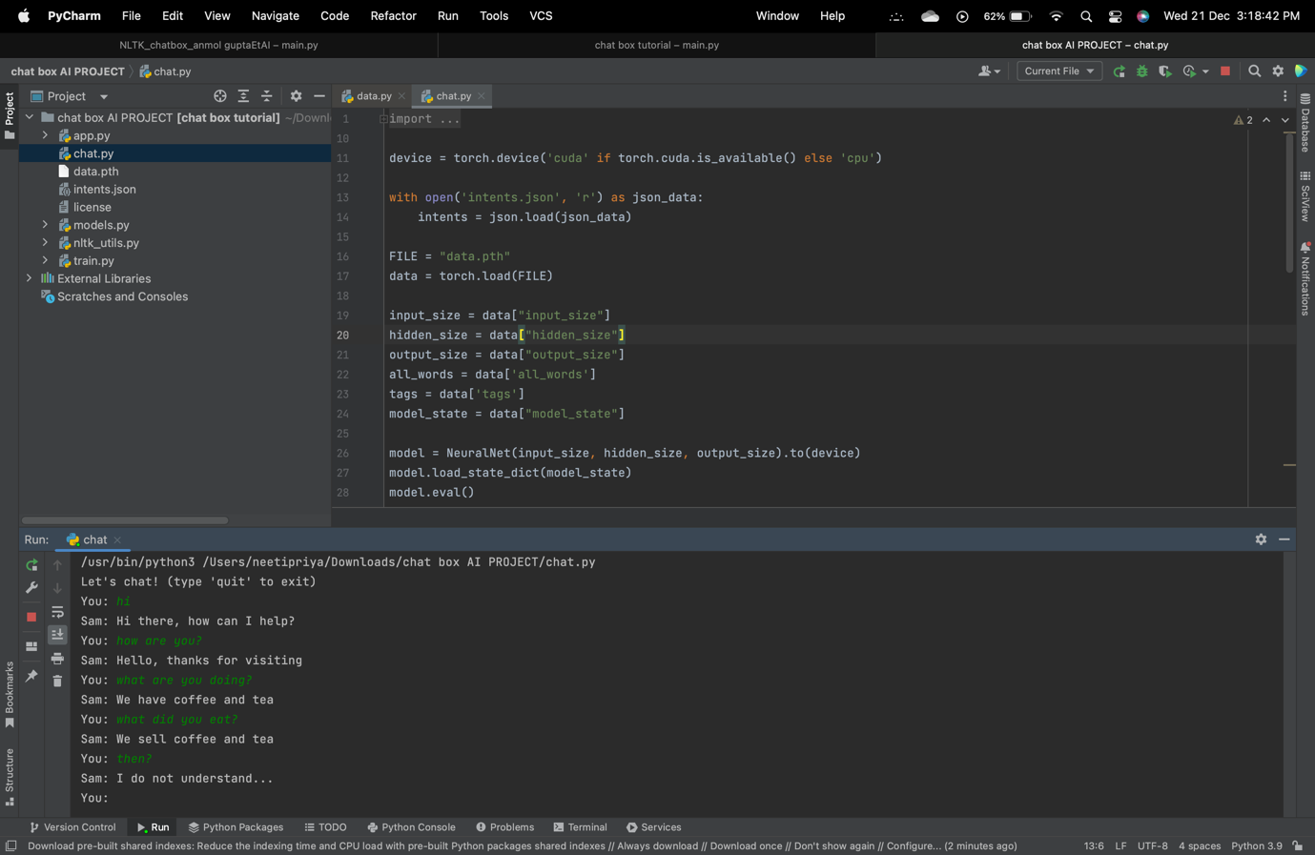

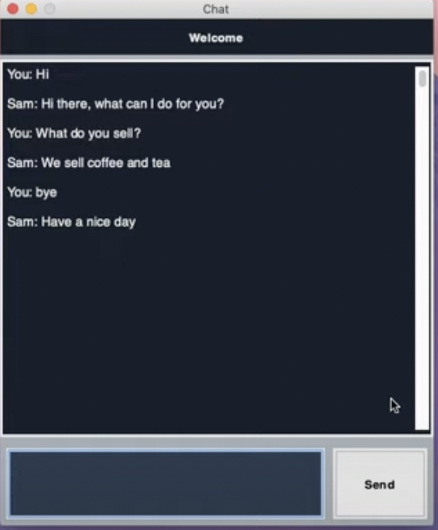

ZIP FILE:-

file:///Users/neetipriya/Downloads/chat box AI PROJECT/chat.py